**16.** **Define creativity. What is meant by “killing of creativity”?**

Creativity :

Creativity management is a system of principles, methods, techniques, practices and instruments for managing employee creativity in order to get the maximum effect for the organization according to its goals, objectives, employee contingent and available resources. • Creativity is nothing but the process of creating something unique and new. • Creativity indeed plays a crucial role in organizations at all levels. Following same old techniques might not yield results every time. • Remember, change is inevitable. You just can’t stick to what was taught in your school or college. • Creativity is reaching to innovative solutions, new ideas and unique concepts through brainstorming, discussions and healthy communication among employees. • You need to understand that same policies can’t be applied everywhere. • Can you apply the same strategy while selling a home and while selling a pen? Absolutely NO. There has to be some difference.

Killing of creativity :

Creativity is the driving force behind many new products, services, and companies around the world, creating solutions to age-old problems and offering new ways to live our daily lives. • Yet despite the indispensable nature of innovation, many businesses don’t exactly foster creativity in the workplace, sometimes even actively working against it. • Whether they realize it or not, there are many ways that businesses kill creativity on a daily basis, which isn’t just bad for those creative minds but also the organization as a whole.

**17.How an entrepreneurship development work?**

Entrepreneurship Development is a practice meant to improve entrepreneurial skills among people. In other words, it is the inculcation, advancement, and grooming of entrepreneurial skills into a person needed to establish and successfully run an enterprise.

**18.** **What are the competencies of a manager?**

Manager competencies are a blend of knowledge, skills, and abilities that effective managers possess. These competencies include:

Communication: Being able to communicate a vision to the team.

Delegation: Managing tasks by involving team members.

Motivating Others: Understanding individual motivations.

Organizing & Task Management: Efficiently managing work.

Patience: Handling challenges calmly.

Building Effective Teams: Fostering collaboration.

Self-development: Continuously improving skills.

**19.** **Describe briefly the reinforcement theory of motivation.**

[**https://youtu.be/xmhHwJ8EaEc?si=RDpDktY-ORnJ2tIF**](https://youtu.be/xmhHwJ8EaEc?si=RDpDktY-ORnJ2tIF)

**20.** **What are the main sources of a leader’s power?**

[**https://youtu.be/Rbbn8qFEut0?si=Q5ZBx2_Jijw5u7TM**](https://youtu.be/Rbbn8qFEut0?si=Q5ZBx2_Jijw5u7TM)

**21.** **Briefly describe the trait theory of leadership?**

[**https://youtu.be/Kz0vC5j8YDk?si=NuyJTlyCZrpNRqPK**](https://youtu.be/Kz0vC5j8YDk?si=NuyJTlyCZrpNRqPK)

**22.** **What was the main premise of Fiedler’s contingency theory?**

[**https://youtube.com/shorts/YsVPswW7OZQ?si=Mt2ceISfOUxHlTVu**](https://youtube.com/shorts/YsVPswW7OZQ?si=Mt2ceISfOUxHlTVu)

**23.** **Name the four combinations of leadership styles according to the Situational Leadership**

**theory?**

[**https://youtu.be/aINJsq3UT74?si=dwokfMQUXwYTJlxI**](https://youtu.be/aINJsq3UT74?si=dwokfMQUXwYTJlxI)

**24.** **What do you understand by “transformation leadership”?**

[**https://youtu.be/aINJsq3UT74?si=dwokfMQUXwYTJlxI**](https://youtu.be/aINJsq3UT74?si=dwokfMQUXwYTJlxI)

**25.** **Discuss the leadership grid.**

[**https://youtu.be/pDa6_quGJ9I?si=ejsJp-PKcYdGV96y**](https://youtu.be/pDa6_quGJ9I?si=ejsJp-PKcYdGV96y)

**26.** **Discuss briefly the path-goal theory.**

[**https://youtu.be/ylfrjIld9aw?si=UoFuRGN_3tczOkOP**](https://youtu.be/ylfrjIld9aw?si=UoFuRGN_3tczOkOP)

**27.** **How many steps involved in the process of decision making?**

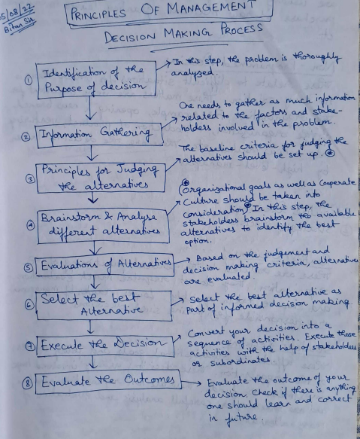

**28.** **Explain the mission, goals and objectives of an organization?**

**Mission:** This is the organization's "why" - its fundamental purpose and reason for existence. It defines what the organization does and the value it provides.

**Goals:** These are broad statements of what the organization wants to achieve in the mid-term, often aligned with the mission. Goals translate the mission into achievable targets.

**Objectives:** Objectives are specific, measurable steps that need to be taken to reach the goals. They are time-bound and clearly define what success looks like for each objective.

**29.Explain the ‘gang plank principle’?**

[**https://youtu.be/LjUeW_DMiqc?si=rDfnD0BQ5h3t8gO8**](https://youtu.be/LjUeW_DMiqc?si=rDfnD0BQ5h3t8gO8)

**30.** **What do you understand by the span of control?**

19th page of the handwritten note